**Sprint 3 – Fit-Track Pro**

**Sprint Planning Meeting Minutes**

**Date:** April 5, 2025  
**Attendees:** Scrum Master, Product Owner, Development Team (Frontend & Backend), QA Team  
**Duration:** 1 hour  
**Discussion Points:**

* Review of Sprint 2 progress and retrospective outcomes
* Prioritized backlog grooming and selection of achievable goals
* Assignment of backlog items to team members
* Discussion on GitHub Actions setup and CICD pipeline

**Decisions Made:**

* Sprint 3 will focus on analytics enhancements, user profile features, and CICD integration.
* Agreed to complete CI pipeline setup with GitHub Actions for testing and builds.

**3rd Sprint Backlog Items**

1. **Analytics Dashboard Enhancements**
   * Weekly/Monthly calorie intake charts
   * Activity comparison trends
2. **Profile Management**
   * Edit user info (height, weight, age, etc.)
   * Update fitness goals
3. **Email Notifications (Basic Setup)**
   * Notify user weekly summary via email (test setup only)
4. **CI/CD Integration**
   * GitHub setup with GitHub Actions for unit testing
   * Auto build trigger on push to main branch
5. **Unit Tests for Meal Logging and Workout Modules**
6. **Basic Integration Test for Profile Update API**

**Burnt Down Chart (Sprint 3)**

**Total Story Points:** 20  
**Sprint Duration:** April 6 – April 19, 2025

|  |  |
| --- | --- |
| Day | Remaining Points |
| 1 | 20 |
| 3 | 17 |
| 5 | 14 |
| 7 | 12 |
| 9 | 10 |
| 11 | 6 |
| 13 | 2 |
| 14 | 0 |

**Sprint Velocity**

**Sprint 1:** 20 story points  
**Sprint 2:** 25 story points  
**Sprint 3:** 30 story points  
**Average Velocity:** ~25 SP/sprint

**GitHub Deployment:**

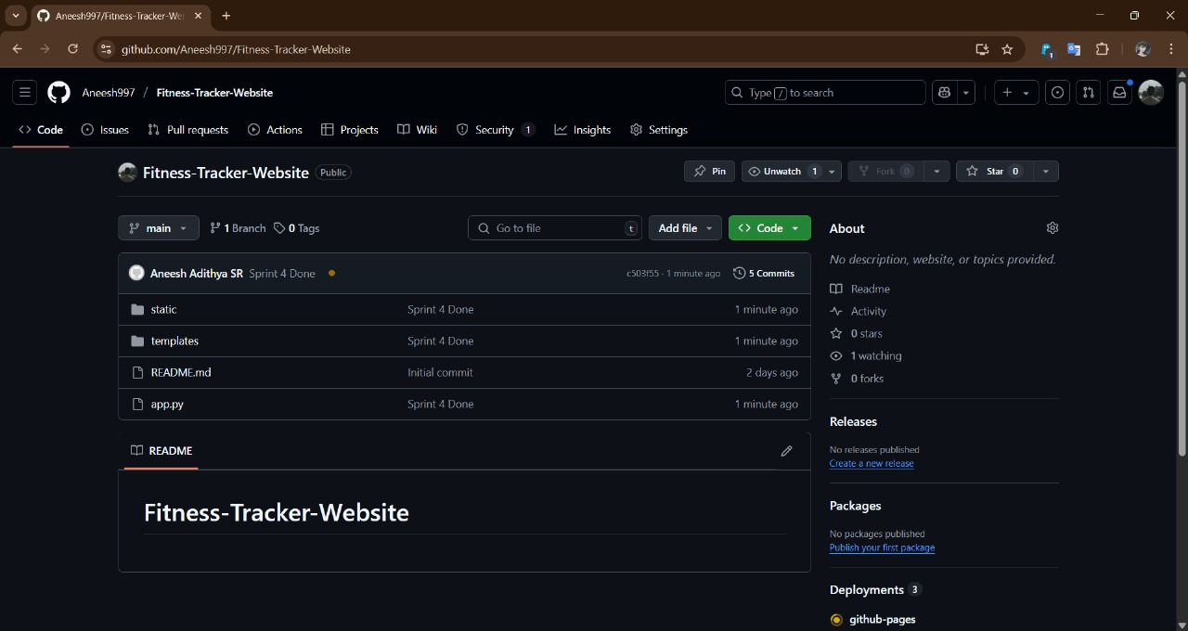

**Sprint 3 Progress:**